LAB EXPERIMENT RECORD
SET 27: Patient Health Risk Analysis

Department | AIML
Course Code / Course Name | DSA0601 / Data Handling and Visualization
Experiment | Data Visualization using R and Tableau
Name | G. GANGA CHANDRIKA
Register Number | 1925260144
Date | 20 October 2026
Day | Tuesday

Aim
To analyse patient health risk data using a scatterplot matrix, Q-Q plot, ECDF and bar chart in R, and to build a Tableau dashboard with a risk heatmap and an Age filter that helps healthcare professionals prioritise patient care.
Dataset: Patient Health Risk Analysis
Patient_ID | Age | BMI | BP | Cholesterol
P1 | 25 | 22 | 120 | 180
P2 | 40 | 28 | 135 | 210
P3 | 55 | 30 | 145 | 240
P4 | 35 | 26 | 130 | 200
P5 | 60 | 32 | 150 | 260

PROGRAM 1: Scatterplot Matrix of Health Indicators
Using R, create a scatterplot matrix for Age, BMI, BP and Cholesterol. Examine pairwise relationships to identify strong correlations, clusters or potential risk patterns.
# Dataset
patient <- data.frame(
Patient_ID = c("P1", "P2", "P3", "P4", "P5"),
Age = c(25, 40, 55, 35, 60),
BMI = c(22, 28, 30, 26, 32),
BP = c(120, 135, 145, 130, 150),
Cholesterol = c(180, 210, 240, 200, 260)
)
print(patient)
# Select health indicators
health <- patient[, c("Age", "BMI", "BP", "Cholesterol")]
# Create scatterplot matrix
pairs(
health,
main = "Scatterplot Matrix of Patient Health Indicators",
pch = 19,
col = "blue"
)
# Calculate correlation matrix
correlation <- cor(health)
print(round(correlation, 2))
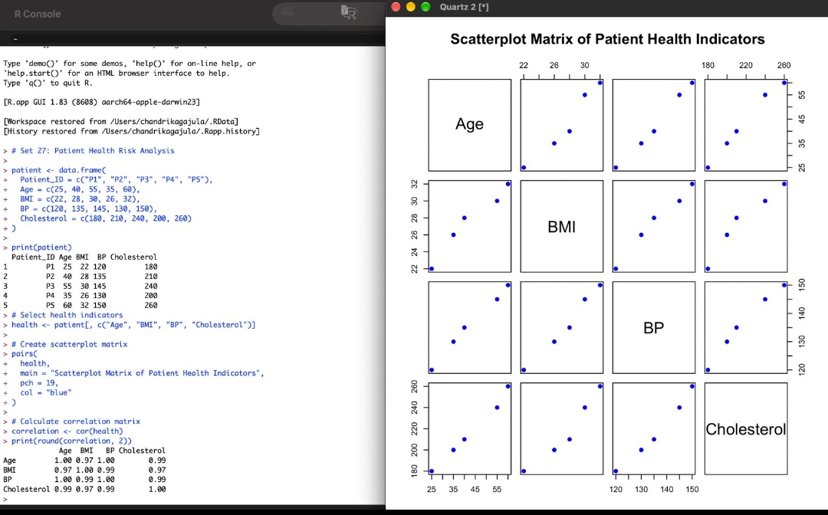
Output 1: Scatterplot Matrix of Patient Health Indicators
Observation: Every pair of indicators shows a tight upward straight-line trend, and all correlations are very strong (about 0.97 to 1.00). Age and BP are almost perfectly correlated (about 1.00), while Age-Cholesterol, BMI-BP and BP-Cholesterol are about 0.99, and Age-BMI and BMI-Cholesterol are about 0.97. The points form two loose groups: P1, P4 and P2 sit in the lower-left (younger patients with lower values), while P3 and P5 sit in the upper-right (older patients with high BMI, BP and cholesterol together). The upper-right group is the potential risk pattern, as the indicators rise together with age. With only five patients, these correlations are indicative rather than conclusive.
PROGRAM 2: Q-Q Plot and ECDF of Cholesterol
Construct a Q-Q plot and an ECDF for Cholesterol levels to assess distribution behaviour. Comment on the normality assumption and skewness.
# Q-Q plot
qqnorm(
patient$Cholesterol,
main = "Q-Q Plot of Cholesterol Levels",
pch = 19,
col = "blue"
)
qqline(patient$Cholesterol, col = "red", lwd = 2)
# ECDF plot
plot(
ecdf(patient$Cholesterol),
main = "ECDF of Cholesterol Levels",
xlab = "Cholesterol",
ylab = "Cumulative Probability",
col = "blue",
lwd = 2,
verticals = TRUE,
do.points = TRUE
)
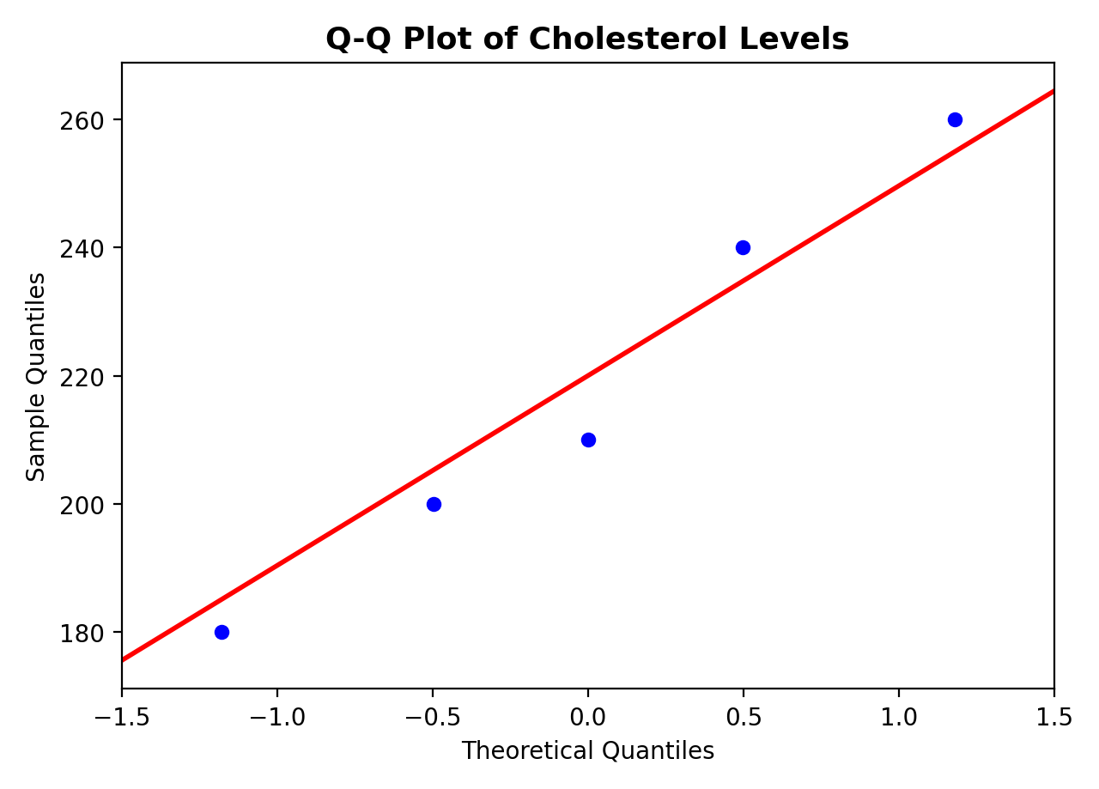
Output 2(a): Q-Q Plot of Cholesterol Levels
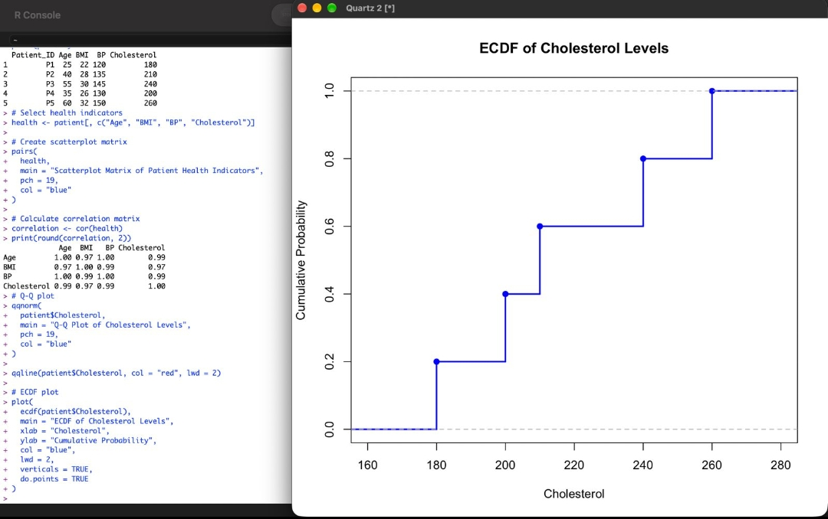
Output 2(b): ECDF of Cholesterol Levels
Observation: In the Q-Q plot the points lie close to the red reference line, with only small departures at the two ends, so the normality assumption is reasonable. The ECDF rises in five equal steps of 0.2 at 180, 200, 210, 240 and 260, reaching 0.6 at the median of 210. The mean (218) is slightly above the median (210) and the upper values are more spread out (210, 240, 260) than the lower ones, which indicates a slight positive (right) skew of about 0.2. The distribution is therefore approximately normal with mild right skewness, although five observations are too few to confirm this formally.
PROGRAM 3: Bar Chart of Average Health Indicators
Using R, create a bar chart showing the average values of each health indicator (Age, BMI, BP, Cholesterol) with axis labels, a descriptive title and distinct colours for each bar.
# Calculate average values
averages <- colMeans(
patient[, c("Age", "BMI", "BP", "Cholesterol")]
)
print(averages)
# Create bar chart
barplot(
averages,
main = "Average Patient Health Indicators",
xlab = "Health Indicators",
ylab = "Average Value",
col = c("skyblue", "orange", "lightgreen", "pink"),
border = "black",
las = 1
)
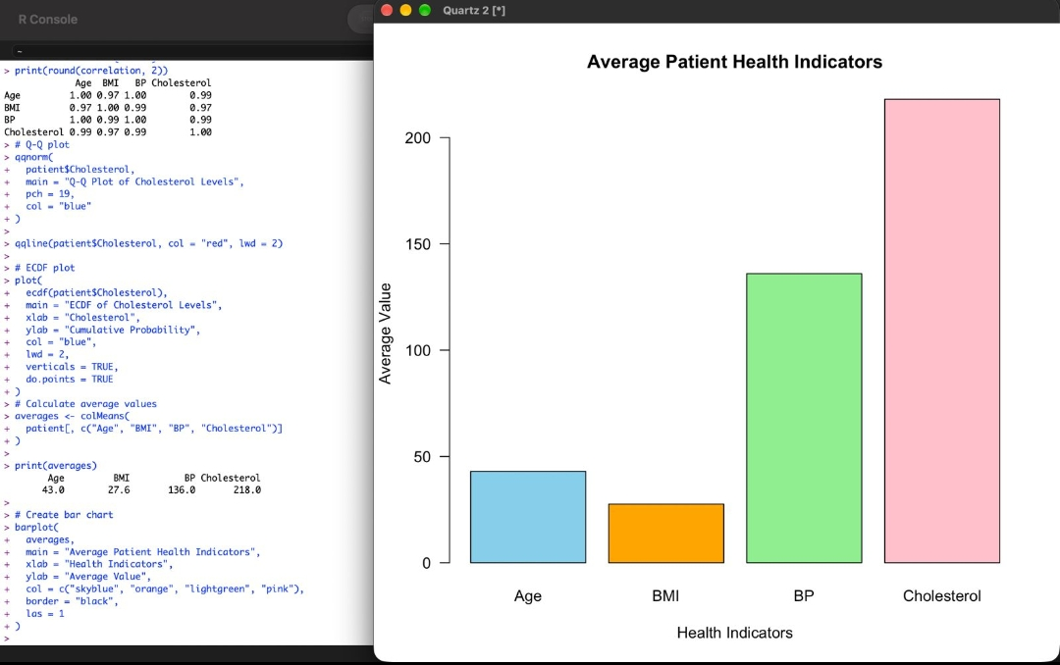
Output 3: Average Patient Health Indicators
Observation: The averages are Age = 43.0, BMI = 27.6, BP = 136.0 and Cholesterol = 218.0. Relative to general health guidelines, an average BMI of 27.6 falls in the overweight range (25 to 29.9), an average systolic BP of 136 is above the normal value of 120 and in the elevated or stage 1 hypertension range, and an average cholesterol of 218 is borderline high (200 to 239 mg/dL). The group as a whole therefore carries a moderate, borderline-to-elevated health risk, and the higher averages are driven mainly by the older patients (P3 and P5).
PROGRAM 4: Risk Heatmap and Interactive Tableau Dashboard
Create an interactive Tableau dashboard with a heatmap highlighting high-risk patients and an Age filter for exploring risk patterns, with hover tooltips showing all health indicators. The risk flags used for the heatmap were prepared in R as shown below.
# Age_Flag, BMI_Flag, BP_Flag and Cholesterol_Flag hold 1 for a
# high-risk value and 0 for a normal value.
# Total number of flags
patient$Risk_Flags <- rowSums(
patient[, c("Age_Flag", "BMI_Flag",
"BP_Flag", "Cholesterol_Flag")]
)
print(patient[, c("Patient_ID", "Risk_Flags")])
# Prepare data for heatmap
heatmap_data <- data.frame(
Patient_ID = rep(patient$Patient_ID, 4),
Indicator = rep(
c("Age", "BMI", "BP", "Cholesterol"),
each = nrow(patient)
),
Flag = c(
patient$Age_Flag,
patient$BMI_Flag,
patient$BP_Flag,
patient$Cholesterol_Flag
)
)
# Create heatmap
ggplot(
heatmap_data,
aes(x = Indicator, y = Patient_ID, fill = factor(Flag))
) +
geom_tile(color = "white") +
scale_fill_manual(
values = c("0" = "lightgreen", "1" = "red"),
labels = c("0" = "No flag", "1" = "Flag"),
name = "Screening status"
) +
labs(
title = "Patient Health Indicator Heatmap",
x = "Health Indicator",
y = "Patient ID"
) +
theme_minimal()
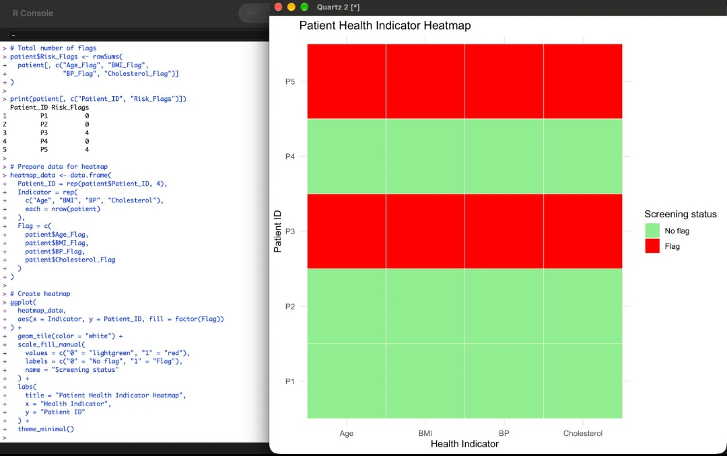
Output 4: Patient Health Indicator Heatmap (red = flagged, green = no flag)
Analysis: P3 and P5 are the highest-risk patients, each with all four indicators flagged (Risk_Flags = 4). P5 is the most critical, being the oldest (60) with the highest BMI (32), BP (150) and cholesterol (260). P1, P2 and P4 have no flags (Risk_Flags = 0).
Effect of age: Risk increases with age. Both flagged patients are 55 or older, while all patients aged 40 or younger have no flags, and BMI, BP and cholesterol rise steadily along with age. Moving the Age filter to the older range isolates exactly the patients who need attention.
Use for healthcare professionals: The red and green heatmap shows at a glance which patients and which indicators need attention. The Age filter lets a clinician focus on a specific age band, and hover tooltips show Age, BMI, BP and Cholesterol for each patient without leaving the dashboard. Together these allow staff to rank patients by number of flags and give early follow-up, medication review or lifestyle counselling to P5 and P3 first.
Set 27 Procedure
1. Create a data frame of Patient_ID, Age, BMI, BP and Cholesterol in R.
2. Select the four health indicators and use pairs() to draw the scatterplot matrix; use cor() to find the correlations.
3. Use qqnorm() with qqline() and plot(ecdf()) to study the distribution, normality and skewness of Cholesterol.
4. Use colMeans() to calculate the average of each indicator and draw the bar chart with barplot().
5. Compute the risk flags and total Risk_Flags for each patient and draw the heatmap of flagged indicators.
6. In Tableau, connect to the patient data, place Indicator on Columns and Patient_ID on Rows, colour the cells by flag (red = flag, green = no flag), add Age as a filter, add all four indicators to the tooltip, and combine the sheets in a dashboard.
Set 27 Result
The patient health data was successfully analysed using a scatterplot matrix, Q-Q plot, ECDF, bar chart and risk heatmap. All indicators are strongly and positively related, cholesterol is approximately normal with mild right skew, and patients P3 and P5 were identified as the highest-risk patients.

